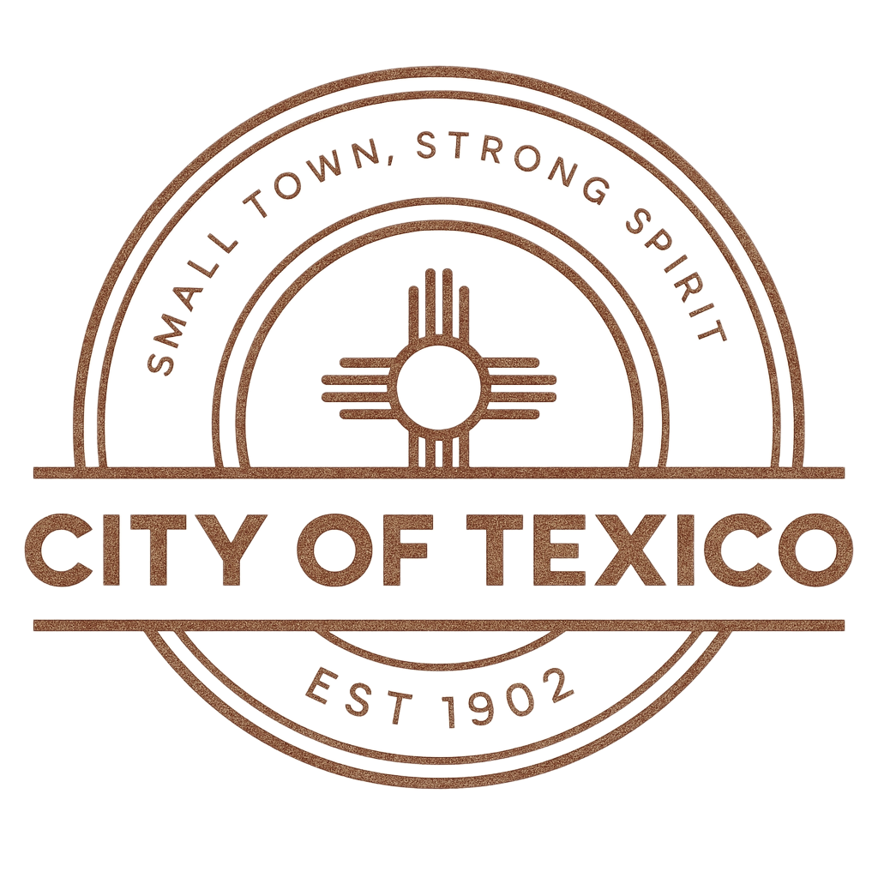
CITY OF TEXICO
CITY COUNCIL REGULAR MEETING AGENDA
“Small Town, Strong Spirit”
Date: May 12, 2026
Time: 4:30 PM
Location: Texico Senior Citizens Building
1. Opening Items
- Prayer
- Pledge of Allegiance
- Roll Call

2. Approval of Minutes: April 28,2026

3. Public Comment

4. Old Business
- Water Conservation – Kenneth Sena PW Supervisor

5. New Business
- Bethany Brzozowski: Program Manager- Curry County Substance Use & Behavioral Health.
- Texico Senior Citizen Area Agency on Aging Program- (discussion & possible action.)
- ENMWUA easement discussion for waterline extension north.
6. Financials
- 3rd Quarter Reports
- Reconciliation Reports

7. Action Items
- EPCOR Inter-governmental Agreement Curry County & City of Texico.

8. Resolutions / Ordinances
- Amended Ordinance 3-411 Joint Utility: (approval for posting)
- Amended Ordinance 6-410 Cemetery: (adoption)

9. Reports of Mayor, Council, Personnel, and Departments

10. Closed Session

11. Announcements
- Next Regular Meeting: Tuesday, May 26, 2026, at 4:30 PM – Texico Senior Citizen Center

12. Adjournment

